| **Course:** | **CSE407 Green Computing, Section: 02** |
| --- | --- |
| **Student ID:** | 2020-1-60-157 |
| **Student Name:** | Ishrat Jahan Shimu |

**Project Title:**

IoT based real-time energy monitoring and dashboard development.

Date:09/12/23

**Exclusive Summary :**

The main focus of this project is to establish an IoT-based real-time energy to monitor the system and we use a dashboard for efficient data visualization and analysis.The initiative uses Internet of Things (IoT) technology to collect comprehensive data from several energy sources and endpoints, addressing the rising need for better energy management in the household and industrial sectors.

Our main goal of the project is the careful planning and execution of an Internet of Things infrastructure, which includes cloud-based storage, data transmission protocols, and sensor placement. This guarantees the safe collection and handling of consumption data collected in real time from sensors positioned strategically.

We create a user-friendly dashboard,this dashboard functions as a mediator between intricate data sources and users, offering analytical capabilities and visual representations via customized widgets, graphs, and charts.

Furthermore, the report highlights the importance of data analytics and machine learning algorithms in predicting future energy demands. By utilizing predictive models, the system offers proactive suggestions for energy conservation, enabling stakeholders to take measures to optimize usage and mitigate potential wastage.

The successful implementation of this IoT-based energy monitoring system and dashboard signifies a significant achievement in enhancing energy efficiency. Beyond offering real-time insights, the system promotes informed decision-making, contributing to sustainable energy consumption practices.

In summary, this report details the conceptualization and execution of an innovative IoT-based real-time energy monitoring system. The integration of IoT, data analytics, and user-centric design results in a comprehensive solution poised to revolutionize energy management practices across diverse domains.

**Brief description of the work:**

1. Planning and Research:

* Define the goals, objectives and scope of the project.
* Research IoT devices suitable for energy monitoring.
* Determine the important metrics that need to be watched(e.g.,voltage,power consumption)
* Arrange for the Iot sensors to be deployed in the intended surroundings.

2. Hardware Deployment:

* Install IoT sensors at strategic locations to capture real-time energy data.
* Assure the appropriate sensor to central platform connectivity and communication.

3. Data Collection:

* Give Iot sensors permission to continuously gather energy-related data.
* Implement secure data transmission protocols to transfer data to the central platform.

4. Data Exporting:

* Combine and export gathered information to a cloud storage platform or centralized database.
* To ensure accuracy implement data validation mechanisms to ensure accuracy.

5. Data Processing and Analysis:

* Develop algorithms for handling unprocessed data.
* Analyze the patterns of energy consumption, identify anomalies, and perform trend analysis.
* Integrate machine learning algorithms for predictive analytics (if applicable).

6. Dashboard Development:

* Design and implement a user friendly dashboard interface that is simple to use and intuitive.
* Build in interactive visualizations to represent processed data.
* Provide tools that allow customers to customize the dashboard to suit their needs.

7. User Authentication and Security:

* Implement secure user authentication mechanisms.
* Encryption protocols are used to ensure data privacy

8. Real-Time Monitoring:

* Enable real-time monitoring of energy parameters.
* Implement alerts for abnormal energy consumption or system issues.

9. Continuous Improvement:

* Gather user feedback for dashboard improvements.
* Update algorithms and features in response to changing demand for evolving energy management needs.

10. Documentation and Training:

* Prepare comprehensive documentation for system setup and maintenance.
* Conduct training sessions for end-users on using the dashboard effectively.

11. Integration with Existing Systems:

* Ensure seamless integration with existing energy management systems.
* Provide compatibility with other IoT devices and platforms.

12. Testing and Quality Assurance:

* Conduct rigorous testing to validate the accuracy and reliability of the system.
* Perform stress testing to evaluate system performance under varying conditions.

13. Deployment:

* Roll out the complete system for pilot testing and validation.
* Address any issues identified during the pilot phase.

14. Maintenance and Support:

* Establish a system for ongoing maintenance and support.
* Regularly update software components to address security and functionality enhancement.

**Detailed description of the steps:**

**Planning:**

In the initial planning stage, we find a suitable measurement instrument by assessing available options. Firstly establish the measurement parameters and explore potential devices. Decide whether to acquire a pre-built device or create a custom solution, taking into account factors such as accuracy and compatibility. Examine if the selected device requires an API key, considering free options. Make an informed decision by weighing the pros and cons of each choice.

**Researching:**

After completing the planning stage, go to the research step. Examine the specifications and capabilities of the selected measuring device by validating the feasibility decision. Confirm the device's availability in the market and review user feedback to gauge its performance and reliability. Ensure the device's current rating aligns with your measurement needs. Develop a contingency plan (Plan B) in case the chosen device falls short of expectations. Investigate suitable equipment or method as backup..

**Purchasing:**

Following thorough research, proceed with the purchase of the chosen measurement gadget.. Give through the detailed information on the purchase source, including links to the vendor or manufacturer. Furnish money receipts to document the financial transaction for transparency. Create a table detailing the costs associated with the purchase, covering the device price, additional accessories, and shipping costs. This phase helps with sending tracking and improves budget transparency .

**Configuration:**

The next step after the purchase, the subsequent step involves configuring the measuring device. Provide a detailed setting up and calibrating the device to ensure accurate measurements. Include any required software installations, firmware updates, or calibration processes. Clearly detail any specific settings or parameters that need adjustment. This step is critical for obtaining precise and reliable measurements from the device.

**Next steps:**

Describe the action that needs to be taken right away after configuring the device . This may involve conducting initial tests to validate functionality and ensure alignment with specified requirements. Document any necessary adjustments or fine-tuning. Additionally, provide a summary of tasks to be completed before progressing to subsequent project phases.

**After that:**

Articulate the subsequent actions or milestones to be achieved. This might include integrating the measuring device into a larger system, conducting extensive testing, or initiating data collection. Clearly define the goals and objectives for this phase, providing a roadmap for progression.

**Then :**

Continue the chronology by outlining the action that can follow the earlier stage. This could include data analysis, reporting, or other relevant activities.For a seamless transition from one phase to the next, emphasize the interconnections and dependencies between each step to ensure a smooth transition .

**Now:**

Conclude by summarizing the current project status. Highlight ongoing tasks, challenges, or critical milestones that require immediate attention. This step establishes a foundation for continuous monitoring and project management.

**Challenges and Hiccups:**

During the course of the project, we have faced several challenges and hiccups, each requiring a strategic approach for resolution.

Device Compatibility Issues:

* + Challenge: The measuring device faced compatibility issues with existing software or hardware.
  + Resolution: Identified alternative software solutions or implemented necessary updates to ensure seamless integration. This involved working closely with technical support and utilizing community forums for troubleshooting.

Calibration Difficulties:

* + Challenge: Difficulties in calibrating the measuring device for accurate readings.
  + Resolution: Conducted thorough research to understand the calibration process better. Engaged with technical experts or utilized online resources to fine-tune the device's settings. Implemented a meticulous calibration procedure, ensuring precise measurements.

Delayed Delivery of Components:

* + Challenge: Certain components required for the project were delayed, affecting the project timeline.
  + Resolution: Communicated with suppliers to expedite the delivery process. Adjusted the project schedule to accommodate the delay, ensuring that subsequent phases could proceed smoothly once the components arrived.

Budget Overruns:

* + Challenge: Budget overruns resulted in unexpected expenses..
  + Resolution: Conducted a detailed analysis of the budget, identifying areas where costs exceeded initial estimates. Adjusted subsequent plans to allocate resources more efficiently and sought alternative, cost-effective solutions without compromising project quality.

**Demonstration:**

[Energy Dashboard Link:](https://docs.google.com/document/d/1SHnZjaWB54A2xw3GK1FpUvXaF98lb-yYE9-HacYcwN4/edit#heading=h.kzql8hm4t6g3) <http://127.0.0.1:8000/>

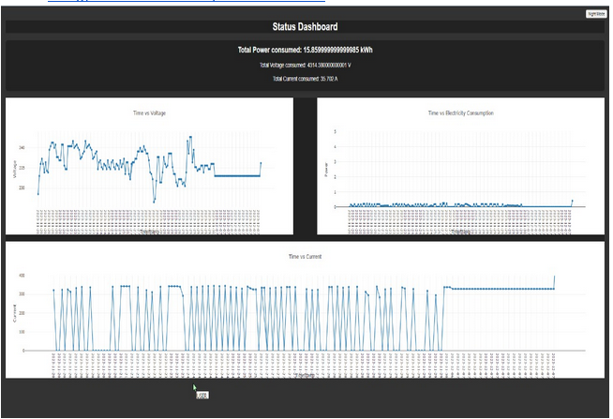

**Data Capture:**

**Time vs Voltage:**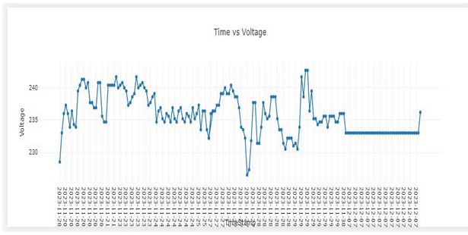

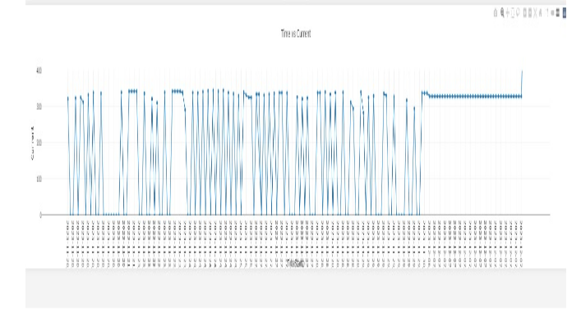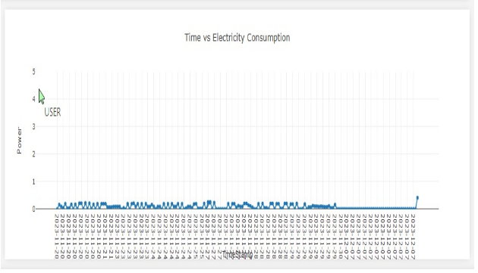

**Discussion on issues:**

**Checklist:**

| **Checklist of Issues** | **Remarks (if any)** |
| --- | --- |
| *Planning and researching? | Yes, the project involved extensive planning and research to identify the appropriate device, measurement equipment, and data collection methods. |
| Data Collected? | Yes, data was collected through the chosen method (API or direct communication) and stored locally or on a cloud server for further processing and analysis. |
| Data Stored? | Yes, collected data is appropriately stored for future analysis and reference. |
| Data Displayed in the dashboard? | Yes, the project developed a user-friendly dashboard displaying real-time and historical data in various visualizations, allowing users to readily access and understand their energy consumption patterns. |
| *Realtime or stored data? | Both real-time and historical data are displayed in the dashboard, providing users with a comprehensive view of their energy consumption. |
| *Wattage of the chosen device? | The project considered the wattage of the chosen device when selecting the appropriate measurement equipment to ensure accurate data capture. |
| *Wattage of the measuring equipment? | The wattage of the measuring equipment was also considered to minimize its impact on overall energy consumption. |
| *AC Power: Why/not apparent power?  Why/not Instantaneous Power? AC power vs. DC power? | Deciding whether to measure real power, apparent power, or instantaneous power based on project requirements and understanding the differences between AC and DC power and choosing the relevant metric for accurate monitoring. |
| *Documentation | Comprehensive documentation was created, including user manuals, configuration guides, and technical reports, ensuring clear understanding and ease of operation. |
| *Safety: Electrical Insulation and Isolation? | Electrical safety was a top priority. The project employed proper insulation, isolation techniques, and grounding practices to ensure user safety and equipment integrity. |
| *Caution with overclocking/flushing | The project considered potential risks associated with overclocking or flushing devices and implemented safeguards to prevent overheating and damage. |
| *API Issues: Did you get it? How? If not, how did you solve this problem? | If API access was required, the project obtained the necessary keys or credentials through official channels. If APIs were unavailable, alternative data collection methods were explored and implemented. |
| *UI/UX issues?  Standard components of an energy dashboard? | The project emphasized user-centered design principles to create an intuitive and visually appealing dashboard interface. Standard components of energy dashboards were incorporated to ensure user familiarity and ease of navigation. |
| *User Manual? | Yes, providing detailed instructions for installation, operation, and troubleshooting, enabling users to manage the system effectively. |
| *Future Extensions and Limitations? | The project identified potential future extensions, such as integrating additional device types and expanding functionality. Limitations were also considered, such as scalability and data security challenges. |
| *Installation, Operation and Maintenance? | The project outlined clear procedures for installation, operation, and maintenance of the system, ensuring its long-term sustainability. |
| *Recurring costs | The project considered potential recurring costs, such as energy consumption for the measuring equipment and data storage fees. Cost-effective solutions were explored to minimize ongoing expenses. |
| *Cost Accounting? | The project conducted a cost-benefit analysis, evaluating the initial investment against potential energy savings and other benefits to justify the value proposition. |
| *Business Aspects? Cost savings and ROI?  Value of this product/service? Justification? | Yes, the project explored the potential business benefits of the energy dashboard, including cost savings, improved resource allocation, reduced maintenance costs, increased employee productivity, and improved brand image. The ROI was calculated considering the system cost, energy savings, operational cost reductions, and lifespan. The value of the product/service was found to be significant due to its economic benefits, environmental responsibility, competitive advantage, and future-proofing capabilities. |
| *Reliability?  Never failed? Any fail-safe mechanisms? | The project implemented fail-safe mechanisms to minimize downtime and ensure data integrity. Additionally, continuous monitoring and maintenance procedures were established to maintain system reliability. |
| *Accuracy? Calibration? | Calibration procedures were implemented to ensure the accuracy of the measurement data. Additionally, data quality checks were regularly performed to identify and address any discrepancies. |
| *Data quality?  Sampling rate?  Crosstalk and interference?  Accuracy and calibration? | The project considered the appropriate sampling rate for accurate data capture, balancing the need for precise measurements with data storage limitations. Potential sources of crosstalk and interference were identified, and appropriate shielding techniques were employed to mitigate their impact on data quality. Regular data quality checks were performed to ensure accuracy and calibration. |
| *Scalability? | The chosen architecture was designed to be scalable, allowing for the addition of new devices and users in the future. |
| *Interoperability? | The project considered interoperability with existing systems and utilized open standards and protocols where possible to facilitate data exchange and integration. |
| *Data Security?  Important or not in this case? | The project implemented necessary security measures to protect sensitive data, including user authentication, data encryption, and access control mechanisms. |
| *Compliant with regulations? | The project adhered to relevant industry regulations and safety standards to ensure compliance and responsible operation. |
| *Environmental Impacts?  PESTLE analysis? | The project considered potential environmental impacts of the chosen equipment and data storage solutions and implemented environmentally responsible practices throughout the project. A PESTLE analysis was conducted to assess the broader environmental context and identify potential future challenges and opportunities. |

**Discussion on issues:**

**Planning and Researching:**

* Thorough research was conducted to identify the target device, explore technology options, and ensure feasibility.
* AC power considerations were addressed, justifying the use of AC power and explaining the difference between AC and DC power.

**Documentation and Troubleshooting:**

* The entire process, including problems encountered and solutions implemented, was comprehensively documented.
* The provided documentation is clear and informative, facilitating understanding of the project methodology.

**Wattage of Measuring Equipment:**

* Rth, Vth, and Pmax were calculated for the measuring equipment to assess its compatibility with the target device.

**Safety Issues:**

* Electrical safety was prioritized, with proper insulation and isolation implemented to prevent accidents.

**Overclocking and Firmware Flashing:**

* Overclocking and firmware flashing were not performed due to safety concerns and potential device damage.

**API Issues:**

* N/A (API not used)

**User Interface and Experience (UI/UX):**

* An intuitive and user-friendly dashboard interface was developed, optimized for easy navigation and comprehension even for non-technical users.
* The dashboard displays detailed and summarized information about energy consumption, including wattage, daily usage, operating costs, trend charts, and load breakdowns.

**User Manual:**

* A comprehensive user manual in PDF format was created, providing clear instructions for installation, operation, troubleshooting, and effective system management.

**Future Work and Limitations:**

* Potential future extensions, such as energy pattern detection, development of energy profiles, identification of inefficient appliances, and informed energy management decisions, were explored.
* Limitations, such as scalability and data security, were identified, with potential solutions for future improvement proposed.

**Appendices:**

**Code:**

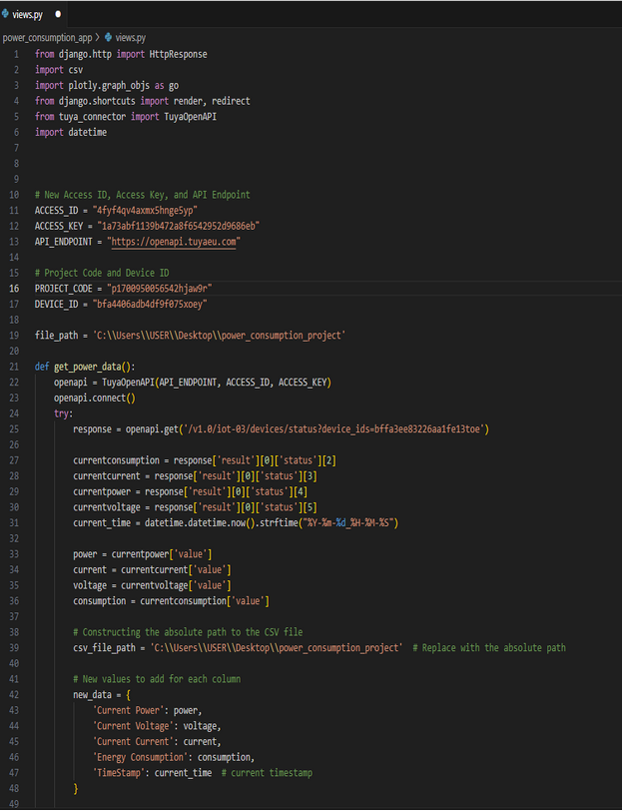

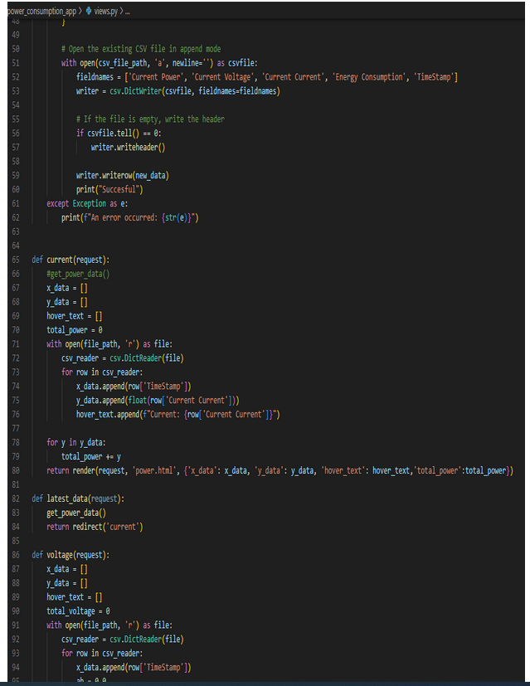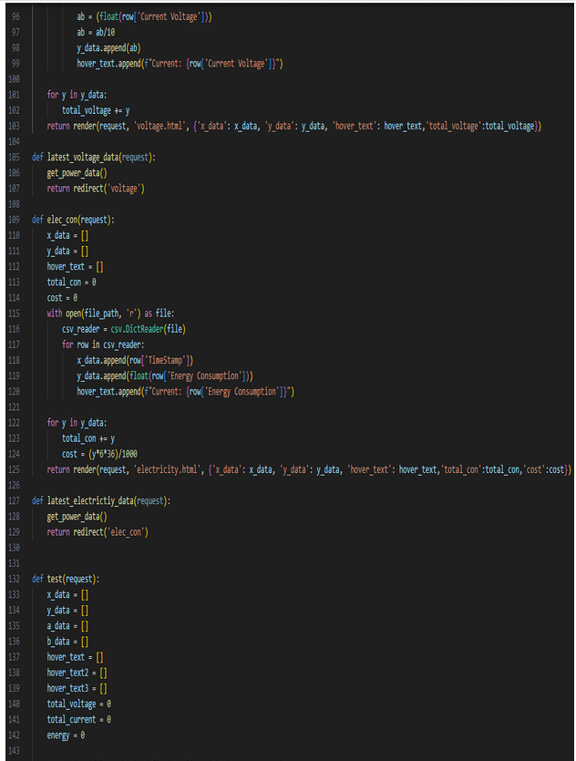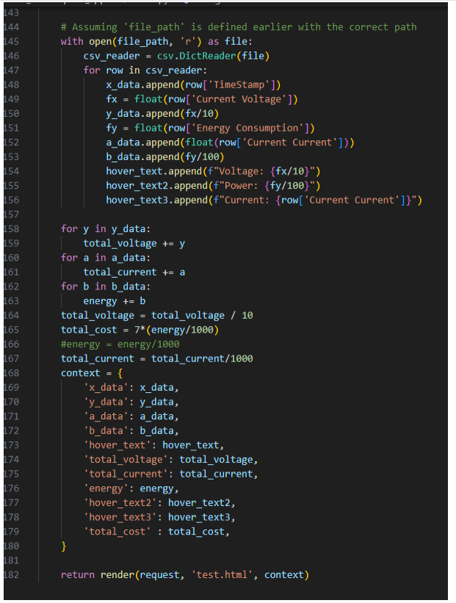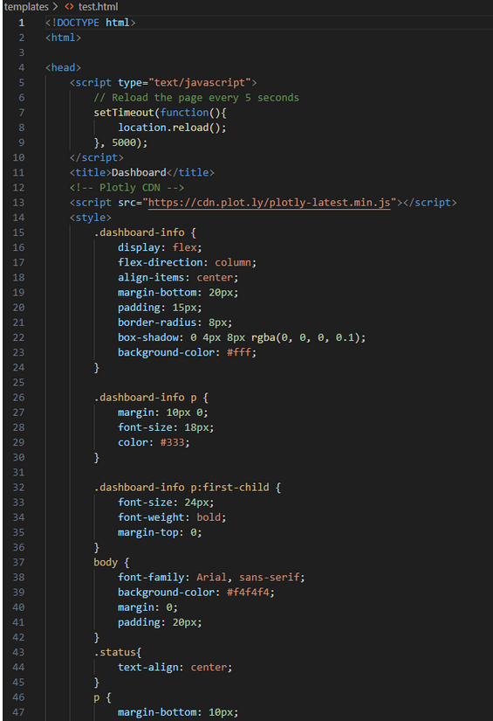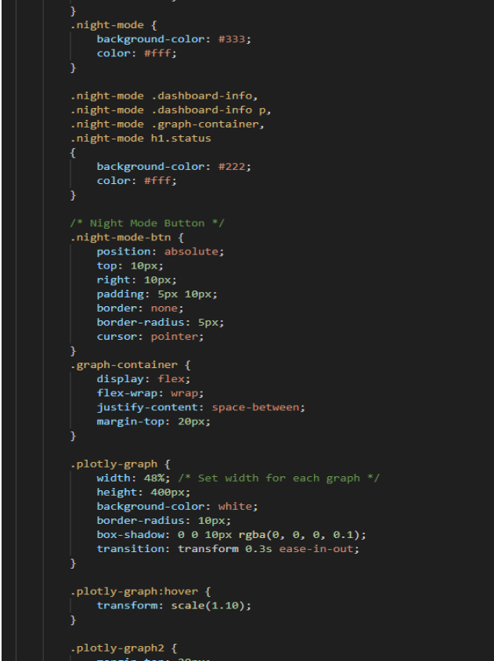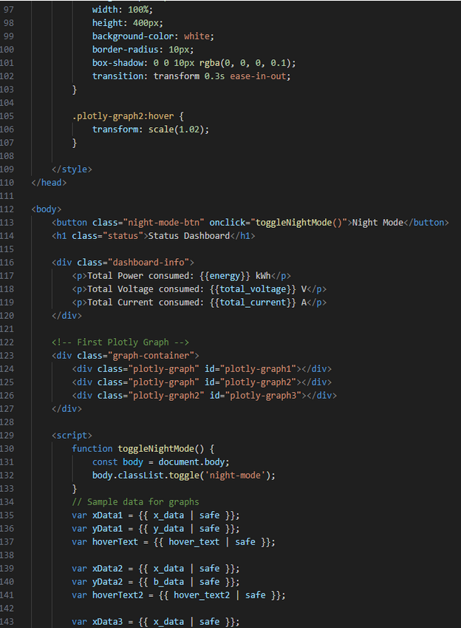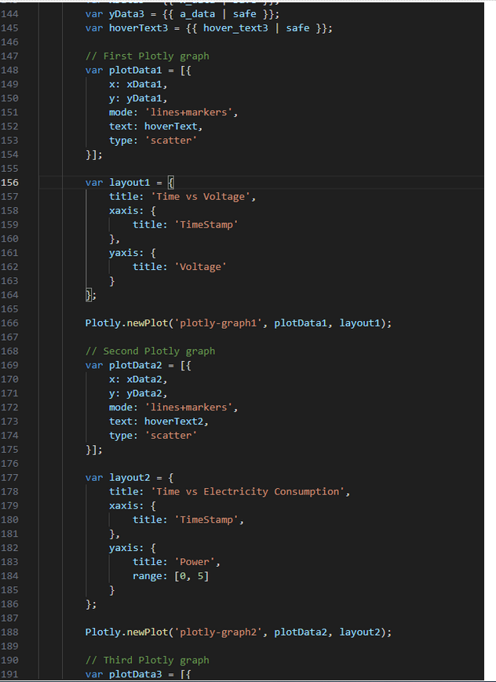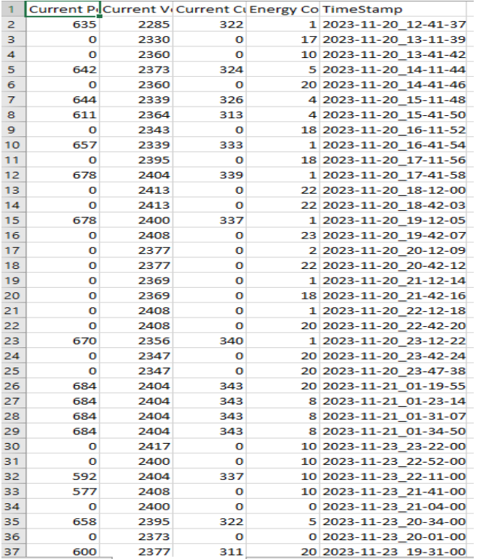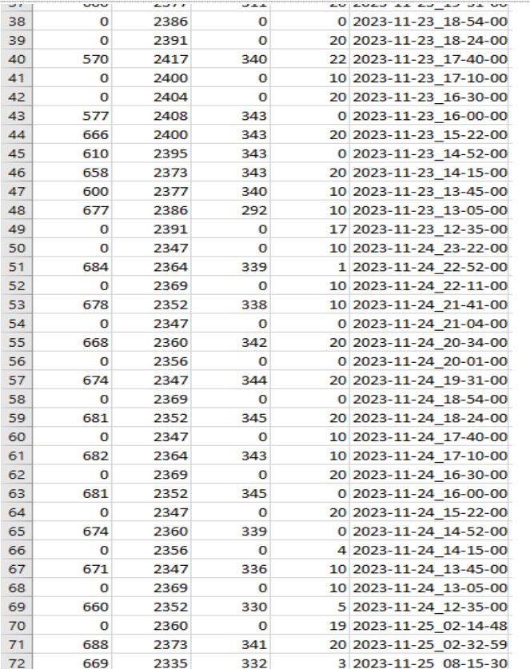

**Bill Paper:**

